1. List all customers and the products they ordered with the order date. (Inner join)

**QUERY:1**

**OUTPUT**

SELECT

c.company_name AS customer, o.order_id, p.product_name, od.quantity, o.order_date

FROM customers c

INNER JOIN orders o ON c.customer_id = o.customer_id

INNER JOIN order_details od ON o.order_id = od.order_id

INNER JOIN products p ON od.product_id = p.product_id

ORDER BY c.company_name, o.order_date;

1. Show each order with customer, employee, shipper, and product info — even if some parts are missing. (Left Join)

Tables used: orders, customers, employees, shippers, order_details, products

**QUERY:2**

SELECT

o.order_id,

c.company_name AS customer,

e.first_name || ' ' || e.last_name AS employee,

s.company_name AS shipper,

p.product_name,

od.quantity,

o.order_date

FROM

orders o

LEFT JOIN

customers c ON o.customer_id = c.customer_id

LEFT JOIN

employees e ON o.employee_id = e.employee_id

LEFT JOIN

shippers s ON o.ship_via = s.shipper_id

LEFT JOIN

order_details od ON o.order_id = od.order_id

LEFT JOIN

products p ON od.product_id = p.product_id

ORDER BY

o.order_id;

**OUTPUT:**

/*3. Show all order details and products (include all products even if they were never ordered). (Right Join)

Tables used: order_details, products*/

**QUERY:3**

SELECT

od.order_id,

p.product_id,

od.quantity,

p.product_name

FROM

order_details od

RIGHT JOIN

products p ON od.product_id = p.product_id

ORDER BY

p.product_id;

**OUPUT:**

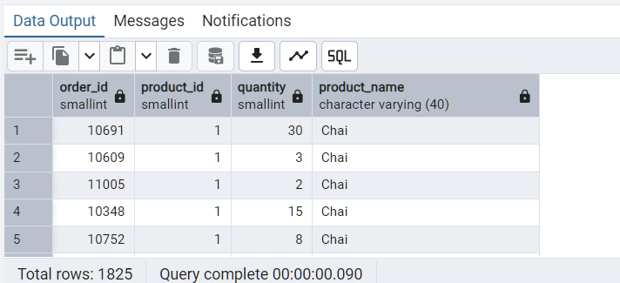

**4.List all product categories and their products — including categories that have no products, and products that are not assigned to any category.(Outer Join)**

**Tables used: categories, products**

**QUERY:4**

SELECT

c.category_name,

p.product_name,

p.product_id

FROM

categories c

FULL OUTER JOIN

products p ON c.category_id = p.category_id

ORDER BY

c.category_name, p.product_name;

**OUTPUT:**

/*5. Show all possible products and category combinations (Cross join).

QUERY:5

SELECT

c.category_name,

p.product_name,

p.product_id

FROM

categories c

CROSS JOIN

products p

ORDER BY

c.category_name, p.product_name;

**OUPUT:**

/*6. Show all employees who have the same manager(Self join)*/

**QUERY:6**

SELECT

e1.first_name || ' ' || e1.last_name AS employee,

e2.first_name || ' ' || e2.last_name AS coworker,

m.first_name || ' ' || m.last_name AS manager

FROM

employees e1

JOIN

employees e2 ON e1.reports_to = e2.reports_to AND e1.employee_id <> e2.employee_id

LEFT JOIN

employees m ON e1.reports_to = m.employee_id

ORDER BY

manager, employee, coworker;

**OUTPUT:**

/*7. List all customers who have not selected a shipping method.

Tables used: customers, orders

(Left Join, WHERE o.shipvia IS NULL)*/

**QUERY:7**

SELECT

c.customer_id,

c.company_name AS customer

FROM

customers c

LEFT JOIN

orders o ON c.customer_id = o.customer_id

WHERE

o.ship_via IS NULL

ORDER BY

c.company_name;

**OUTPUT:  
**